ML Algorithms

Naïve Bayes Classifier:
Naive Bayes is arguably the fastest and simplest classification algorithm, yet it powers massive systems (like standard Email Spam Filters).

The Core Analogy: "The Medical Diagnosis"
Imagine you are a doctor. A patient walks in coughing. You need to decide: Do they have the Flu or just an Allergy?
You look at past data:
- "In the past, 90% of people with the Flu were coughing."
- "In the past, only 10% of people with Allergies were coughing."
Using this probability, you can make a mathematical guess. That is Naive Bayes.

This algo depends on Conditional Probability

Conditional Probability:
Conditional Probability: "The Filter"
Standard probability asks: "What is the chance of rain?" Conditional probability asks: "What is the chance of rain GIVEN that it is cloudy?"
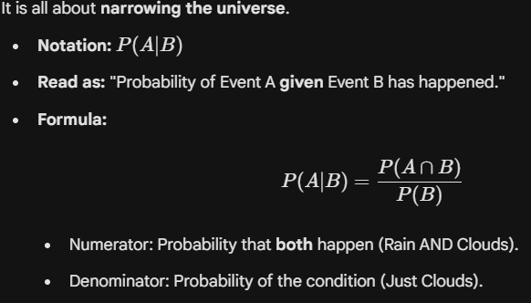

Naive Bayes is essentially Conditional Probability in Reverse.

Bayes Theorem:
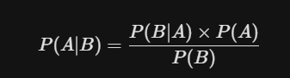
Proof (not needed for extra)


he "Naive" Part (The Assumption)
Why is it called Naive? Because it makes a stupid assumption: It assumes that all features are independent of each other.

calculation for the probability of a specific class (C_{k}) given some data (X).
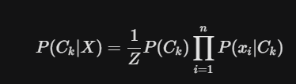
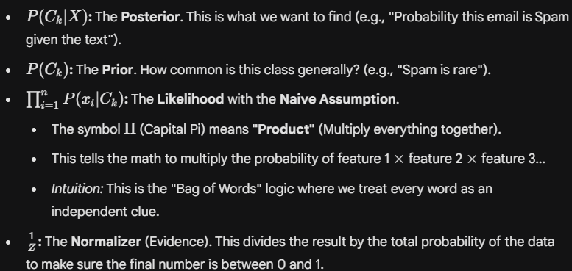

Decision Step.
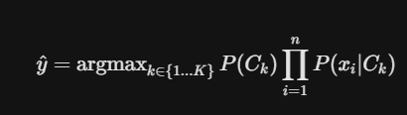
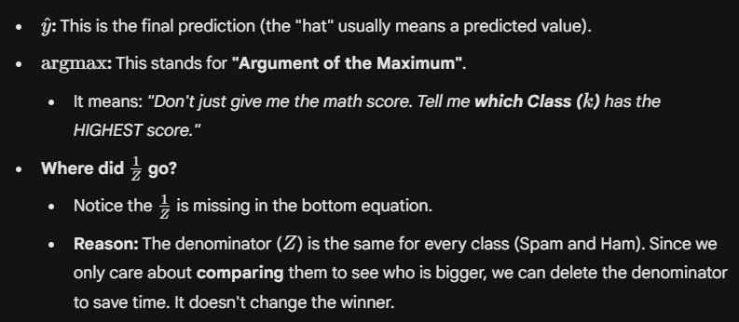

"Maximum a Posteriori Rule (MAP)".
- This is the formal name for the logic: "Pick the class that has the highest probability after looking at the data."
- It is the standard decision rule used in Bayesian classification.

